Newtons Method

Numerical Computation

Lilybeth Delgado

Project #4

Results: The following are the results with the Newtons Method which involves evaluating a root at a given point, therefore using derivatives. We were provided a function, where we passed through our function and an estimated a point that is close to the root. The newtons method gave us an accurate approximation to the root with the least amount of iterations. Based on the screenshot below we can see that for both roots, we found that the max iterations were 3 and the least amount was 2 iterations. I used the previous graphs from the bisection method to estimate the roots, when passing the value x0. Root 1: -5.7591131 , Root 2: -3.668877

Extra Credit:

|  |  |  |  |  |
| --- | --- | --- | --- | --- |
| Root 1: -5.7591131 | Bisection | Secant | False | Newton Method |
| Absolute Approximation Error | 20 | 5 | 16 | 3 |
| Absolute Relative Error | 18 | 5 | 16 | 3 |
| Absolute True Error | 18 | 4 | 7 | 2 |

|  |  |  |  |  |
| --- | --- | --- | --- | --- |
| Root 2: -3.668877 | Bisection | Secant | False | Newton Method |
| Absolute Approximation Error | 23 | 7 | 9 | 3 |
| Absolute Relative Error | 23 | 6 | 9 | 3 |
| Absolute True Error | 18 | 6 | 5 | 2 |

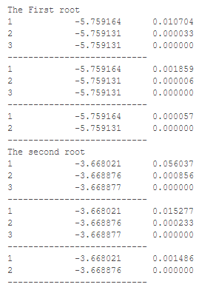As we can see from the table based on Bisection,

Figure : Newtons Method

Secant False position and Newtons method, the smallest

amount of iterations overall was through the Newtons

Method, although we here we had to estimate our point

While in the other methods we used an interval, it makes

Sense as to why using derivatives, it converges faster to

Our root.